DO NOT OPEN THIS EXAMINATION PAPER UNTIL YOU ARE TOLD BY
THE SUPERVISOR TO BEGIN

Grade 9 Mathematics
Final Examination
June 2013

Student Name: ____________________________________

Teacher Name: ____________________________________

Total Value: 70 marks Time: 2 Hours
GENERAL INSTRUCTIONS

1. Candidates are required to do all items.

2. This examination is marked out of 70 and has a total of 16 pages consisting of the following parts:

Part I: 35 Multiple Choice Items Value: 35 marks (50%)
Part II: 12 Constructed Response Questions Value: 35 marks (50%)

3. Part I should be completed on the answer sheet provided on Page 17 of the exam. This page may be removed.

4. Answers to the constructed response questions for part II are to be placed on this paper in the spaces provided.

5. For PART II items, candidates are reminded to show ALL necessary steps and calculations. Partial credit may be awarded for logical work even though you might not arrive at the correct solution. Correct answers without appropriate calculations will not merit full marks.

6. A self powered calculator may be used for calculations and to obtain special values.

REGULATIONS FOR CANDIDATES

Candidates are expected to be thoroughly familiar with all regulations pertaining to their conduct during examinations. Candidates must comply with all requirements governing the following matters.

- Materials required  - Leaving the room  - Materials not permitted  - Models of calculators permitted | - Use of pen or pencil  - Use of unauthorized means and penalties  - Completion of required information  - Communication during the exam

PART I
Total Value: 35 marks (50%)

1. What is the square root of $\frac{4}{9}$?
A) $\frac{16}{81}$
B) $\frac{2}{9}$
C) $\frac{2}{3}$
D) $\frac{8}{9}$

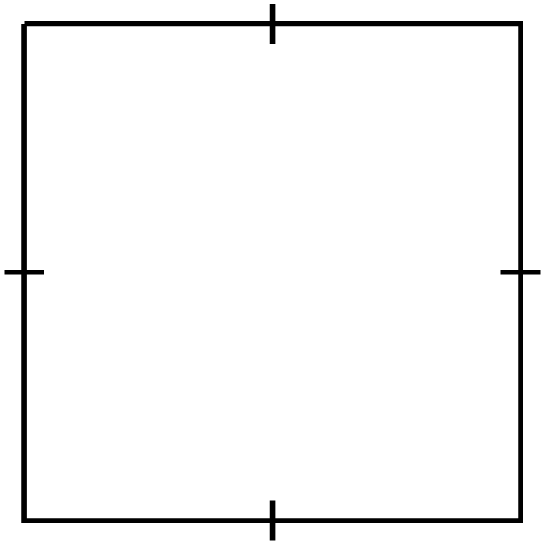2. What is the approximate side length, in centimetres, of the square?
A) $7.1$
B) $14.3$
Area = 204 cm²
C) $51$
D) $102$

3. Which decimal has a square root between $0.7$ and $0.8$?
A) $0.5625$
B) $0.75$
C) $0.8625$
D) $1.50$

4. Evaluate: ${\left(-5\right)}^{0}$
A) $-1$
B) $0$
C) $1$
D) $-5$

5. Evaluate: $3^{4}- 3^{2}$
A) 6
B) 9
C) 72
D) 729

6. What is $-7×-7×-7 ×-7 ×-7×-7$ as a single power?
A) $6 × -7$
B) ${-7}^{6}$
C) ${-(7)}^{6}$
D) ${(-7)}^{6}$

7. What is $5^{6}×5^{6}÷5^{4}$ as a single power?
A) $5^{3}$
B) $5^{8}$
C) $5^{9}$
D) $5^{32}$

8. Which are rational numbers? $\sqrt{\frac{9}{16}}, \sqrt{2.5} , 0.41\overline{6}, \frac{-33}{5}, \frac{π}{2}$
A) $\sqrt{\frac{9}{16}}, 0.41\overline{6}, \frac{-33}{5}$
B) $\sqrt{2.5}, 0.41\overline{6}, \frac{-33}{5}$
C) $0.41\overline{6}, \frac{π}{2}, \frac{-33}{5}$
D) $\sqrt{\frac{9}{16}}, \frac{π}{2}, \frac{-33}{5}$

9. Which expression is equivalent to $7.65$?
A) $\left(2.25+6.75\right)÷2.5-1.25$
B) $2.25+\left(6.75÷2.5\right)-1.25$
C) $2.25+6.75÷(2.5-1.25)$
D) $(2.25+6.75)÷(2.5-1.25)$

10. Which shows $-0.6, -0.\overline{6}, -0.66$ ordered from least to greatest?
A) $-0.66, -0.\overline{6}, -0.6$
B) $-0.6, -0.\overline{6}, -0.66$
C) $-0.\overline{6}, -0.66, -0.6$
D) $-0.6, -0.66, -0.\overline{6}$

11. Evaluate: $-0.4-\left(\frac{-3}{8}\right)$
A) $-0.775$
B) $-0.025$
C) $0.025$
D) $0.775$
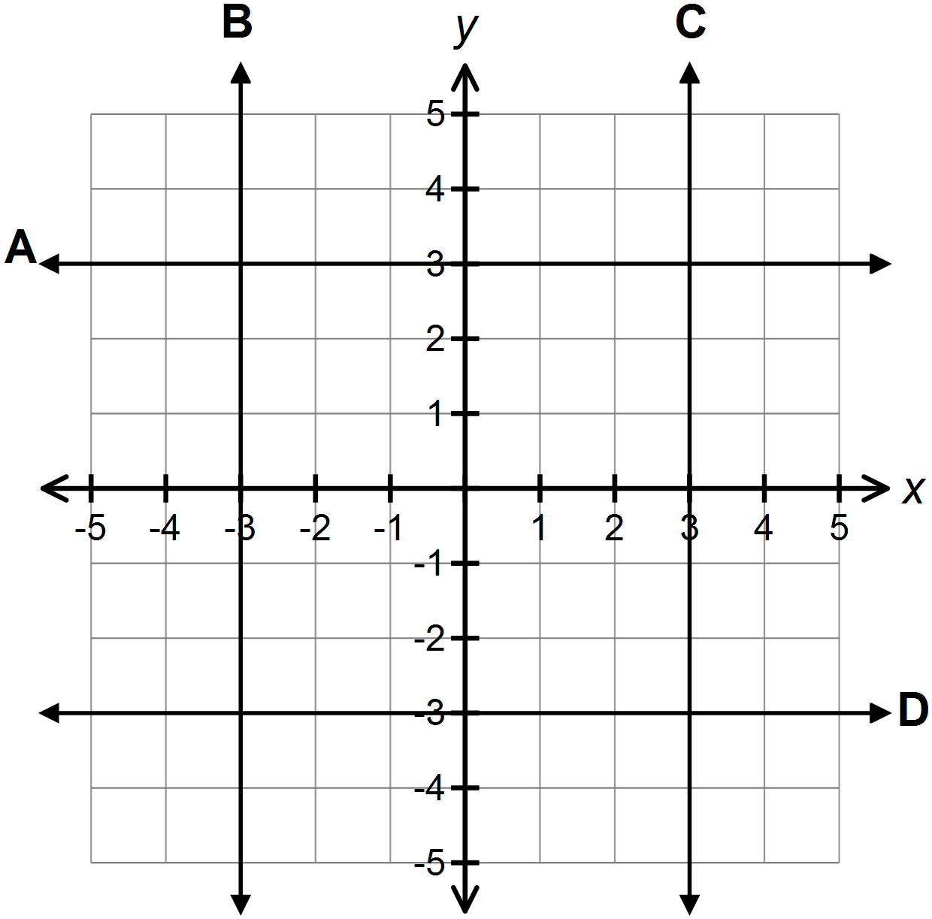
12. Which graph shows $x=-3$?
A) A
B) B
C) C
D) D

13. For the linear relation, what is the value of $x$ when $y= -2$?
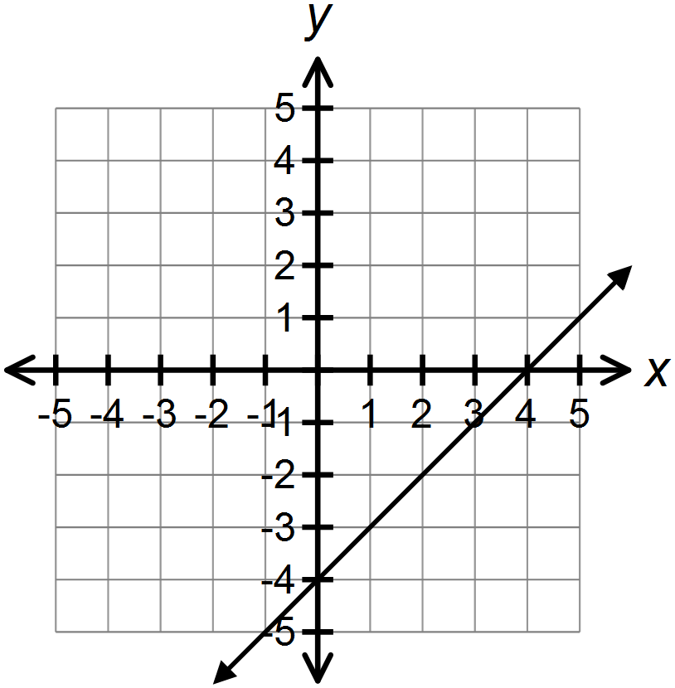
A) -6
B) 2
C) 4
D) 6

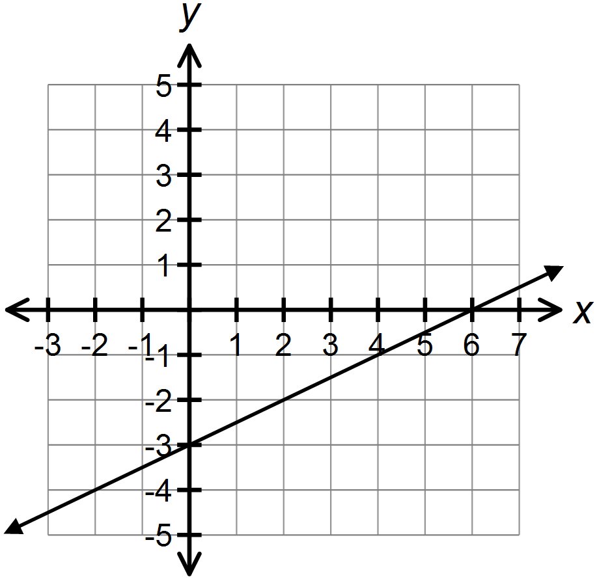14. Which equation represents the graph?
A) $-2x+y=6$
B) $x-2y=6$
C) $3x-y=3$
D) $6x-3y=0$

15. Which equation relates the term value, $v$, to the term number, $n$?
$$n$$ | $$v$$
$$-2$$ | $$-1$$
$$-1$$ | $$2$$
$$0$$ | $$5$$
$$1$$ | $$8$$
$$2$$ | $$11$$

A) $n=3v+5$
B) $n=5v+3$
C) $v=3n+5$
D) $v=5n+3$

16. Which represents a binomial with a degree of $2$, a coefficient of $5$ and a constant term of $-3$?
A) $5(2n-3)$
B) $5n^{2}-3$
C) $5n^{2}-6n-3$
D) $2n^{5}-3$

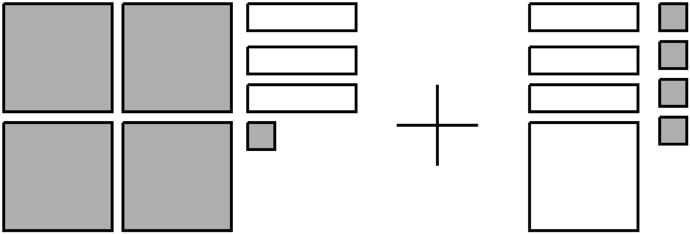17. Which polynomial is modeled by the algebra tiles? [shaded is positive]

A) $-5n^{2}+6n-5$
B) $-3n^{2}+6n-5$
C) $3n^{2}-6n+5$
D) $5n^{2}-6n+5$

18. Which model represents the perimeter of the rectangle? [shaded is positive]
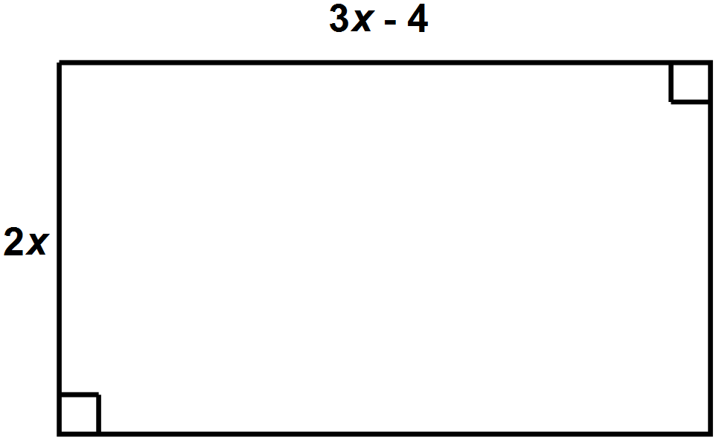

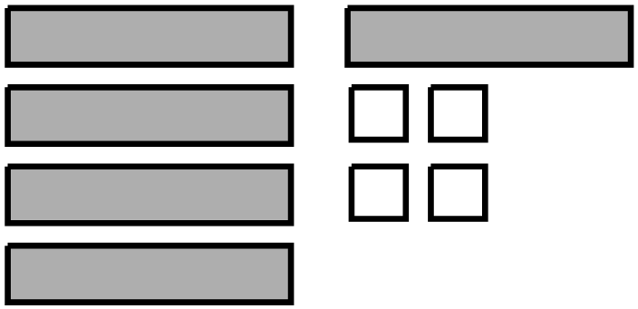A)

B)

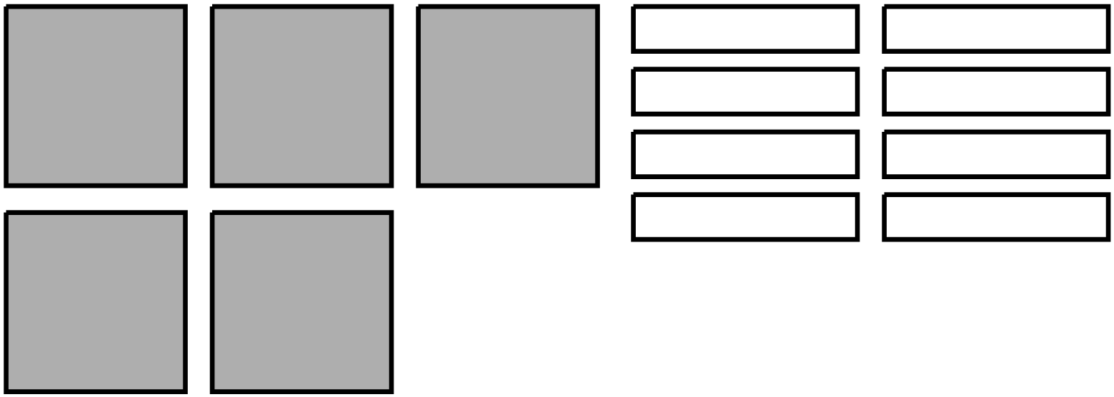C)

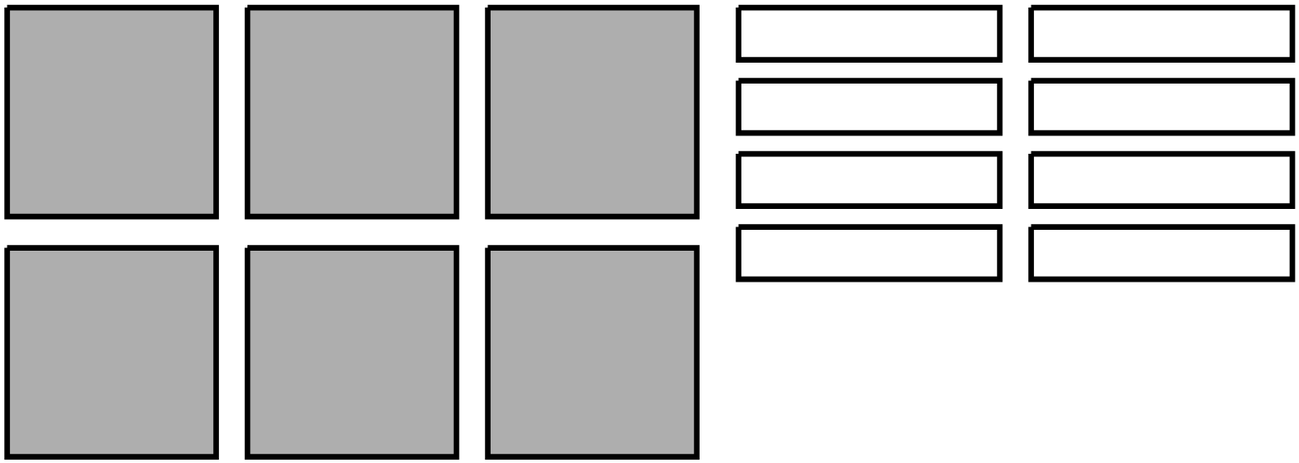
D)

19. Simplify: $\left(5n^{2}-7n+1\right)-\left(-4+4n+3n^{2}\right)$
A) $-3-11n+2n^{2}$
B) $-3-3n+2n^{2}$
C) $5-11n+2n^{2}$
D) $5-3n+8n^{2}$

20. Which is the solution to the equation $-2x+1=9$?
A) $x= -5$
B) $x= -4$
C) $x=4$
D) $x=5$

21. Which equation has a solution of $-3$?
A) $\frac{1}{3}\left(x-9\right)= -4$
B) $\frac{1}{3}\left(x-9\right)= 4$
C) $\frac{1}{3}\left(x+9\right)= -4$
D) $\frac{1}{3}\left(x+9\right)= 4$

22. Which represents the solution to $-2x<6$?
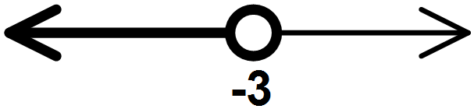A)
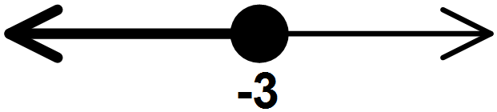B)
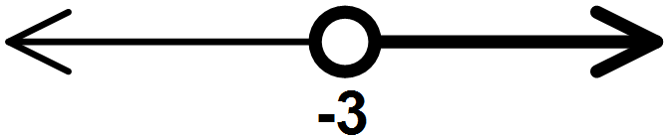C)
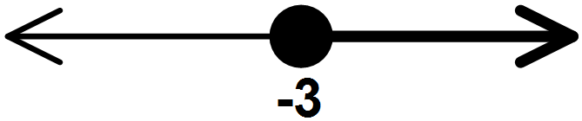D)

23. Solve: $0.2p+1.2=-1.4p$
A) $p=-2.8$
B) $p=-0.75$
C) $p=0.75$
D) $p=1$

24. Which equation represents the statement “seven less than one-fifth of a number is the same as twice that number increased by one?”
A) $\frac{1}{5}n-7=2n-1$
B) $\frac{1}{5}n-7=2n+1$
C) $7-\frac{1}{5}n=2n-1$
D) $7-\frac{1}{5}n=2n+1$

25. How many lines of symmetry are in a rhombus?
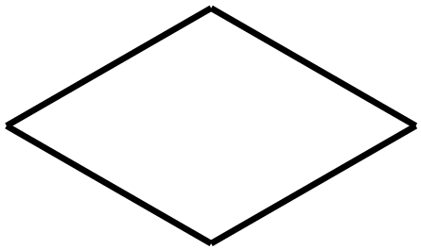A) 1
B) 2
C) 3
D) 4

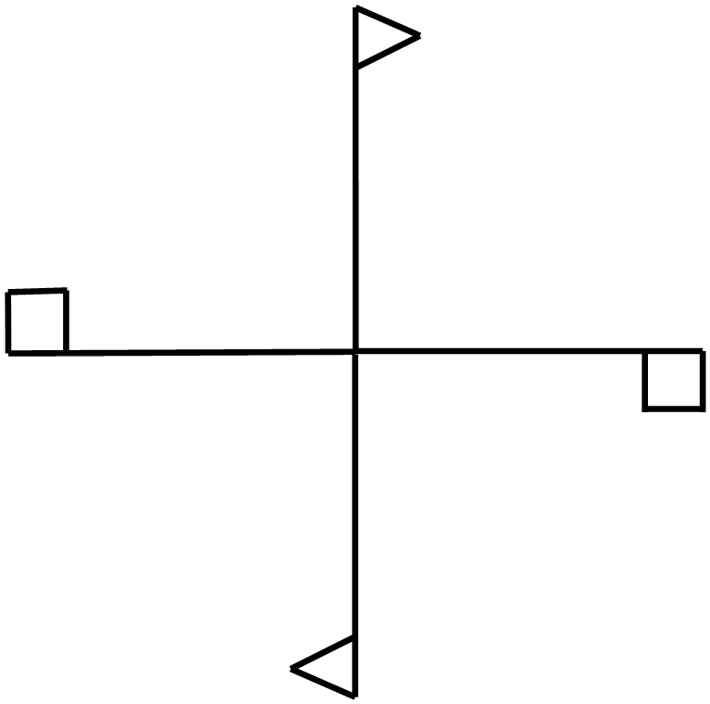26. What is the angle of rotation for the figure?
A) $90°$
B) $180°$
C) $270°$
D) $360°$

27. A scale factor of $0.5$ is applied to the triangle. Which is the resulting image?
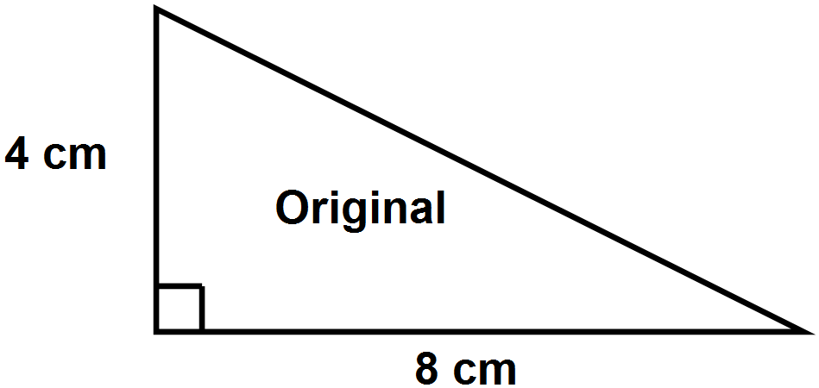

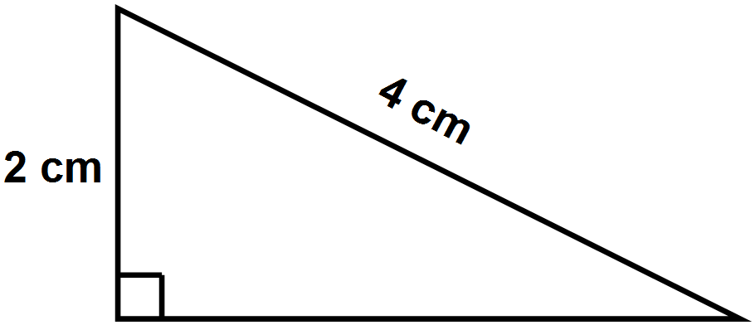 A)

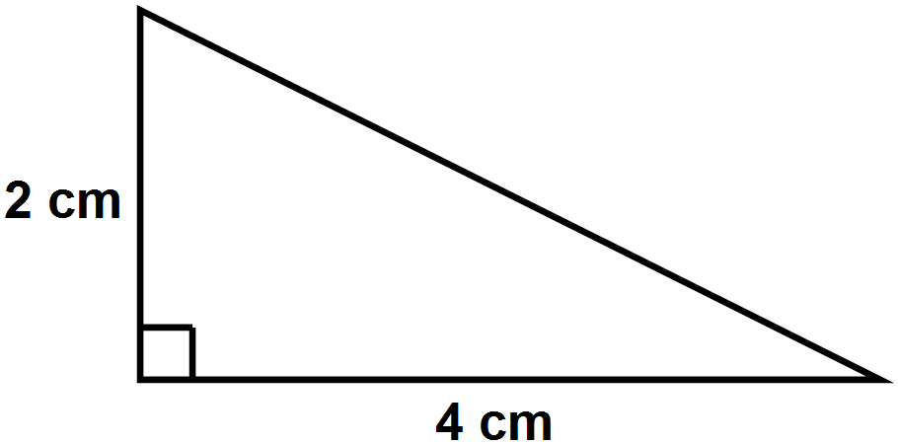
B)

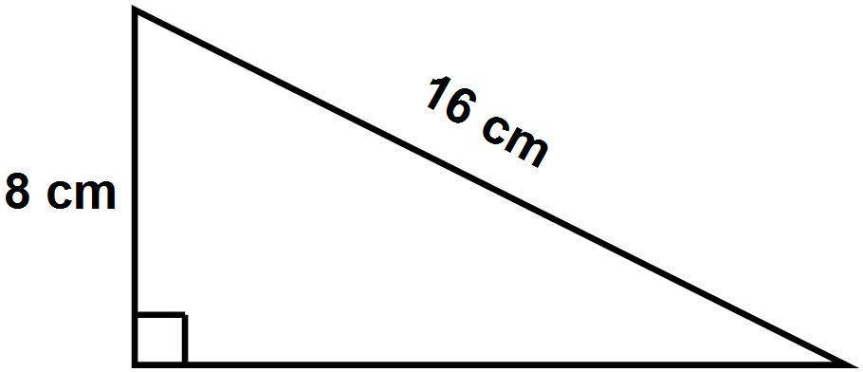
C)

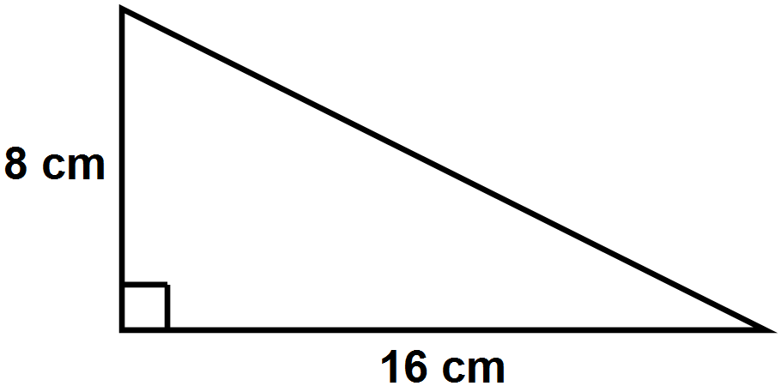
D)

28. Which diagram is similar to the original?
A) A  B) B  C) C  D) D | 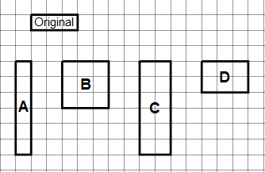

29. If the y-axis is the line of symmetry, what are the coordinates of $A'$?
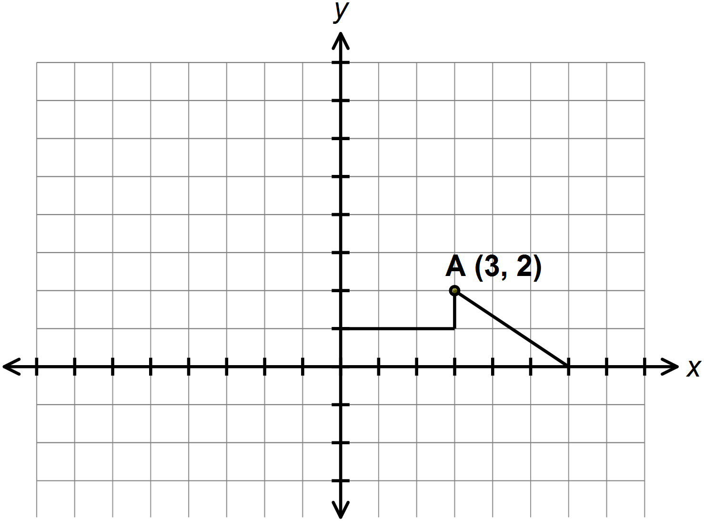 A) $(-3, -2)$
B) $(-3, 2)$
C) $(3, -2)$
D) $(3, 2)$

30. Point $O$ is the centre of a circle. What is the value of $x$??
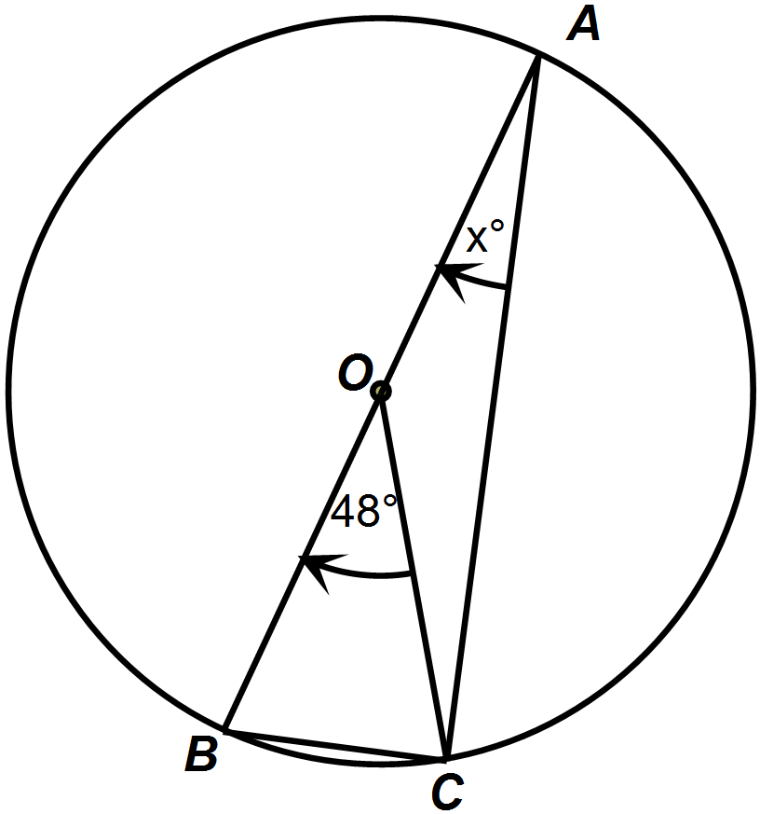
- $24°$

- $42°$

- $45°$

- $48°$

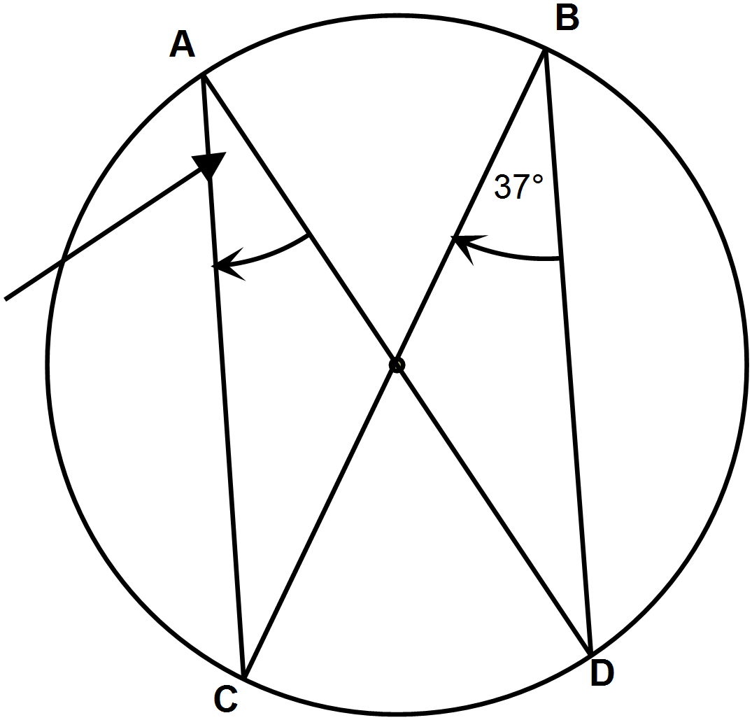31. What is the value of $x$?
A) $17$
B) $20$
$$(2x-3)°$$
C) $37$
D) $74$

32. Point $O$ is the centre of a circle. $\overline{PQ}$ is tangent to $\overline{OP}$. What is the measure of
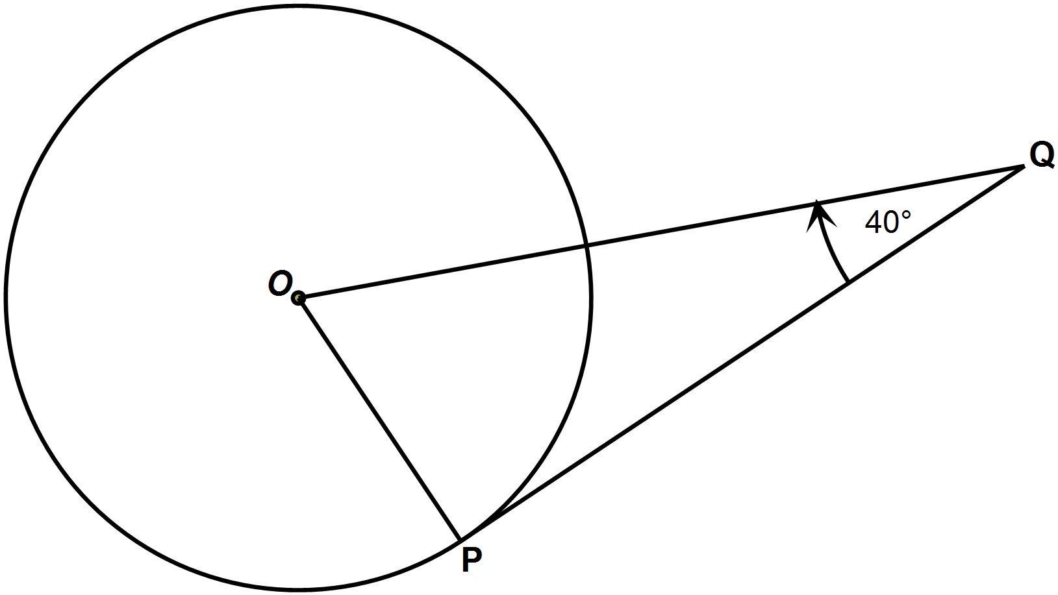$OPQ$?
A) $50°$
B) $70°$
C) $80°$
D) $90°$

33. Point $O$ is the centre of a circle with a radius of $15 cm$ and $OF=9 cm$.
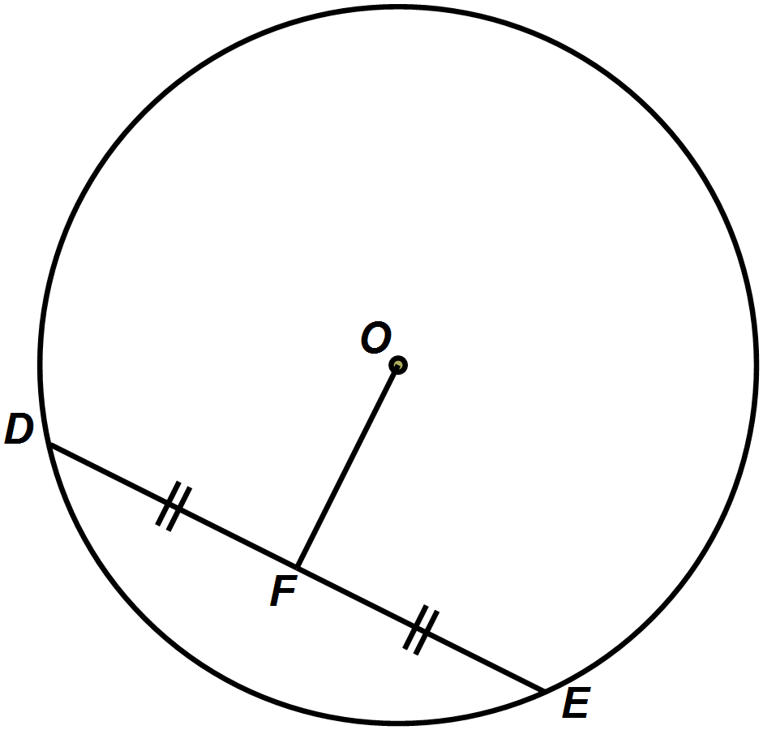What is the length of $DF$?

A) $6 cm$
B) $9 cm$
C) $12 cm$
D) $17.5 cm$

34. Which situation represents bias?
A) bus students are asked about their views on the new bus route
B) mall shoppers are surveyed about their opinions on the new food court design
C) people at a pop machine are asked to choose their favorite type of beverage
D) teenagers are questioned about their favorite winter activities

35. Which situation represents a population?
A) election outcomes are predicted based on a random survey
B) grade 9 students are required to receive vaccinations
C) health of fish stocks are regularly monitored
D) one in ten smartphones are tested for defects

PART II Show all workings
Total Value: 35 marks (50%)

value
4 36. The composite figure is made from a cylinder and square-based prism. What is the total surface area of the figure, including the bottom?

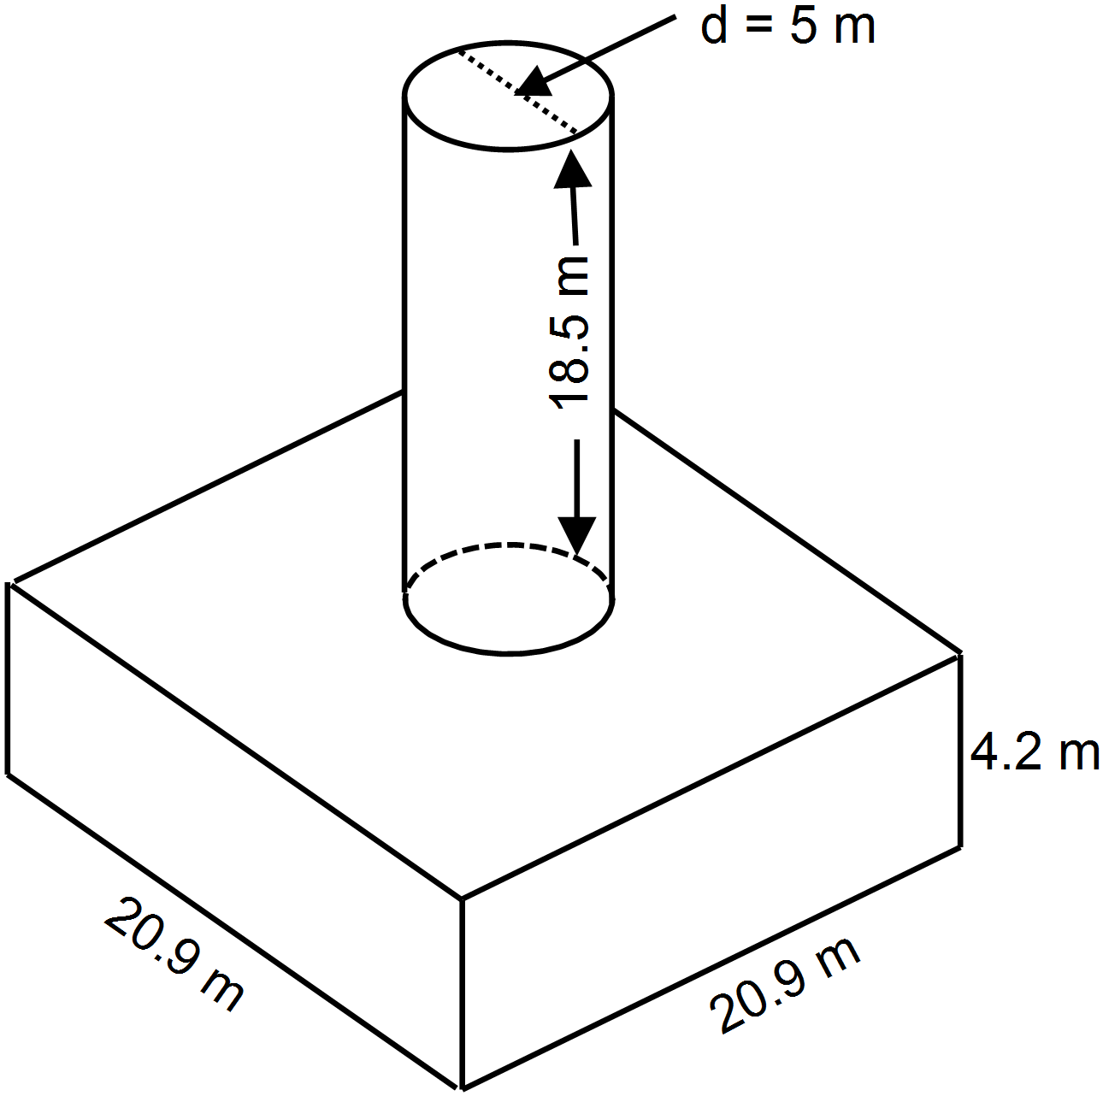Surface Area of a Cylinder = $2πr^{2}+2πrh$
OR $2πr^{2}+πdh$

3 37. Simplify using the laws of exponents and then evaluate:

$$\frac{3^{7}×{\left(2^{3}\right)}^{2}×3^{2}}{3^{9}×2}$$

3 38. Evaluate: $\left(1\frac{1}{3}×\frac{-5}{12}\right)÷\left(-\frac{4}{9}\right)$ Show all workings in fractional form.

3 39. Evaluate: $\frac{1.072 - 3.6 ÷ (-1.8)}{{(1.5 - 4.7)}^{2}}$ Show all steps.

2 40. Complete the table and graph $2x+y=6$
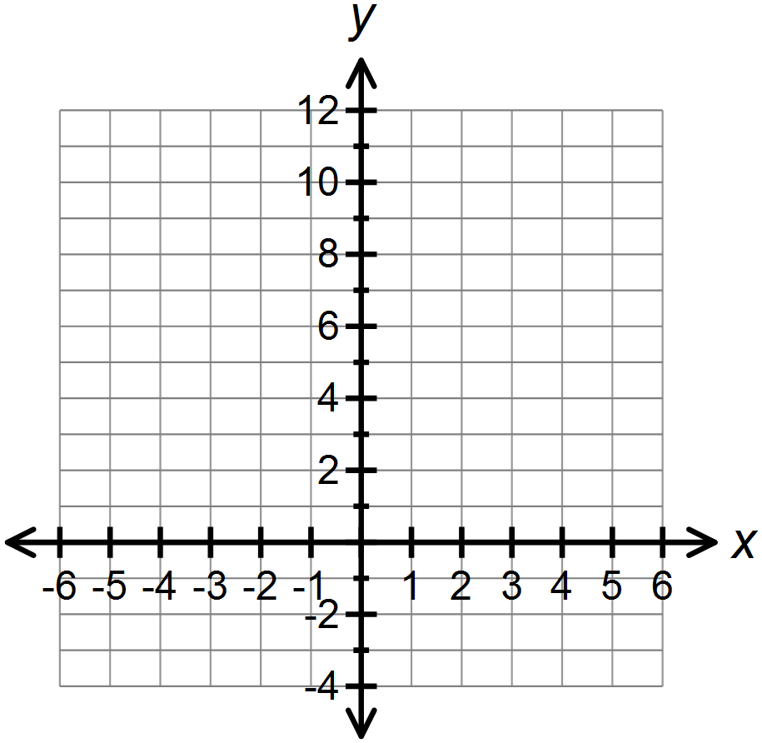
$$x$$ | $$y$$
-2

-1

0

1

2

41. An amusement park charges an entry fee of $10 and $2 per ride.

1 A) Complete the table

# Rides (R) | Cost ($)  (C)
0
1
2
3
4
5

1 B) Write the equation that relates the cost (C) to the number of rides (R).

1 C) How many rides can a person go on if they have $26? Justify your answer.

1 D) Is this an example of continuous or discrete data. Explain your answer.

3 42. Determine the algebraic expression that represents the shaded region. Simplify your answer.
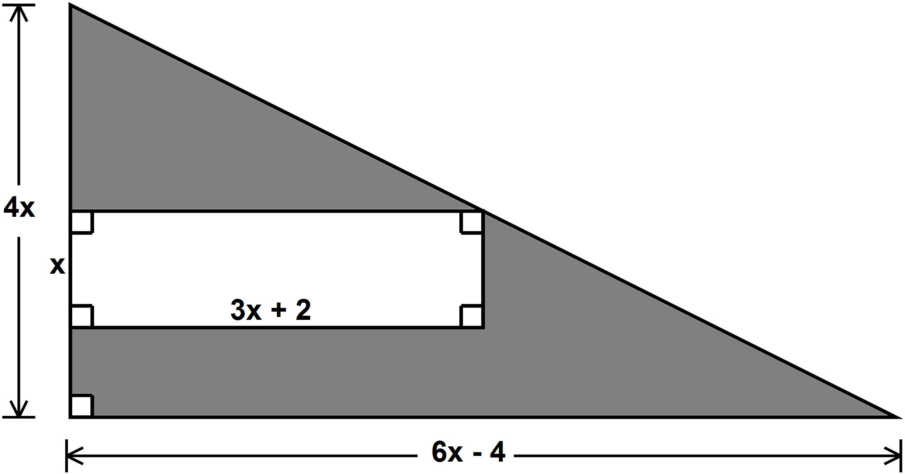

43. Debbie incorrectly solved the following problem:

$4\left(x-5\right)=28$
Step 1 $4x-5=28$
Step 2 $4x-5+5=28+5$
Step 3 $4x=33$
Step 4 $\frac{4x}{4}=\frac{33}{4}$
Step 5 $x= \frac{33}{4}$

1 a) In which step did Debbie’s error occur?

The error occurred in Step __________________

Explanation:

1 b) Solve the equation correctly.

44. John downloads apps from two online stores. The rate plans are shown in the table.

 | iApps | Galaxy Apps
Membership fee | $$\$20$$ | $$\$30$$
Cost per app | $$\$1.25$$ | $$\$0.75$$
Expression | $$20+1.25x$$ | $$30+0.75x$$

3 Write and solve an inequality to determine when the number of iApp downloads costs more than Galaxy Apps downloads.

2 45. Draw a reduction of the figure using a scale factor of $\frac{3}{4}$?

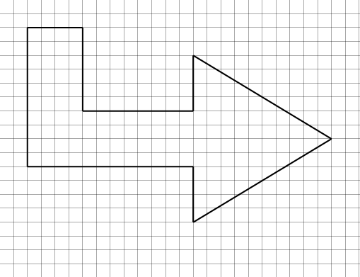

3 46. Both triangles are similar. How long is the bridge?
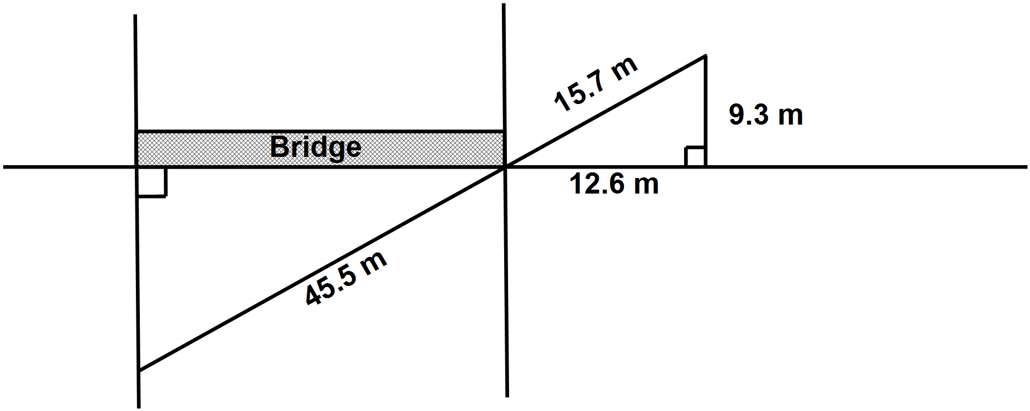

3 47. Point $O$ is the centre of a circle with radius of $7 cm$. If $PQ=16 cm$, what is the length of tangent $RQ$, to the nearest tenth?

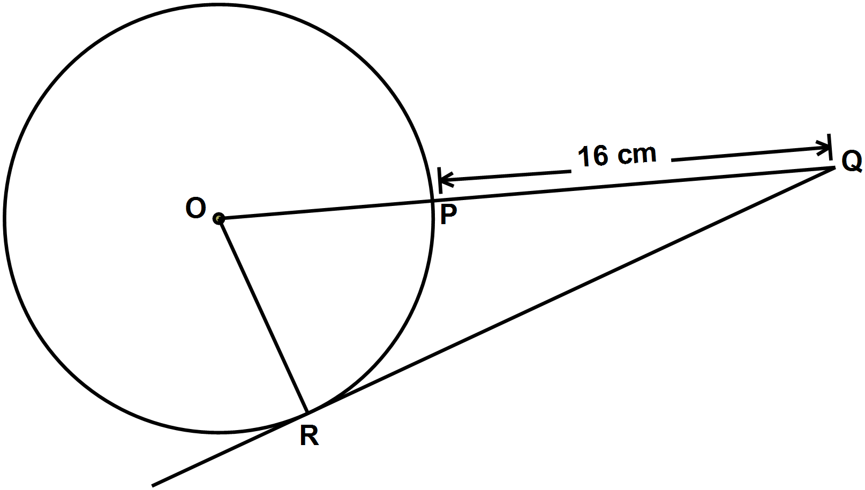

Grade 9 Math Multiple Choice Answer Sheet
(This sheet may be removed from the exam paper.)

Teacher:_________________ Name:_________________

1.
2.
3.
4.
5.
6.
7.
8.
9.
10.
11.
12.
13.
14.
15.
16.
17.
18.
19.
20.

21.
22.
23.
24.
25.
26.
27.
28.
29.
30.
31.
32.
33.
34.
35.

