Sample Answer Key
PART II Show all workings
Total Value: 35 marks

value
4 36. The composite figure is made from a cylinder and square-based prism. What is the total surface area of the figure, including the bottom?

Surface Area of a Cylinder = $2πr^{2}+2πrh$
OR $2πr^{2}+πdh$

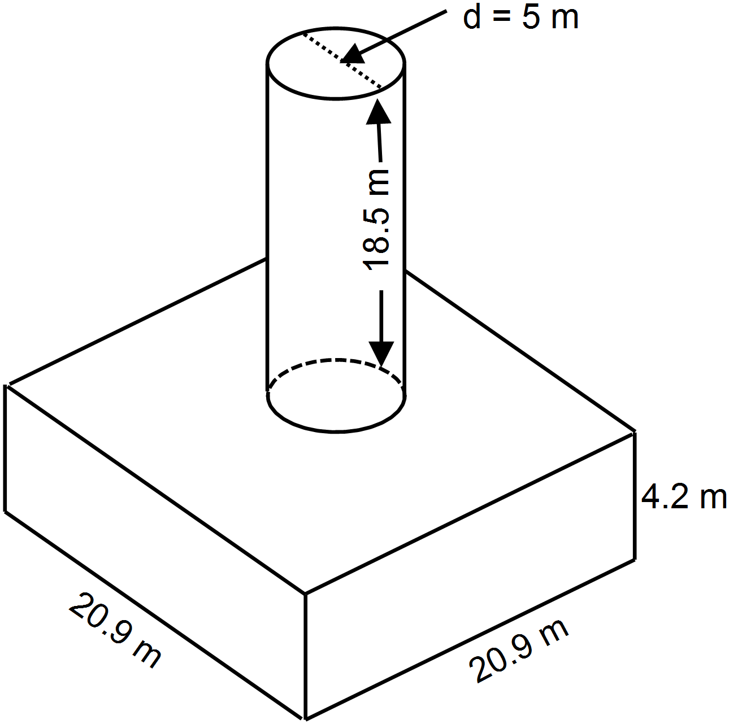
Cylinder 1 mark
$$2\left(3.14\right){\left(2.5\right)}^{2}+\left(3.14\right)\left(5\right)\left(18.5\right)$$
$$=329.7m^{2}$$
Prism 1.5 marks
Top/Bottom
$$2\left({20.9}^{2}\right)=873.62m^{2}$$
Left Side/Right Side
$$2\left(20.9)(4.2\right)=175.56m^{2}$$
Front/Back
$$2\left(20.9)(4.2\right)=175.56m^{2}$$
Total
$$873.62m^{2}+2\left(175.56m^{2}\right)$$
$=1224.74m^{2}$

Area of Overlap 0.5 mark
$$2\left(3.14\right){\left(2.5\right)}^{2}$$
$$=39.25m^{2}$$

Total Surface Area 1 mark
$$1224.74+329.7-39.25 =1515.19{ m}^{2}$$

Note: Some students may readily see that there is no need to find the top and bottom of the cylinder as 2 circles cancel out the overlap.
3 37. Simplify using the laws of exponents and then evaluate:

$$\frac{3^{7}×{\left(2^{3}\right)}^{2}×3^{2}}{3^{9}×2}$$

$\frac{3^{7}×2^{6}×3^{2}}{3^{9}×2}$ 1 mark

$\frac{3^{9}{ × 2}^{6}}{3^{9} × 2}$ 0.5 mark

$2^{5}$ 1 mark

$32$ 0.5 mark

3 38. Evaluate: $\left(1\frac{1}{3}×\frac{-5}{12}\right)÷\left(-\frac{4}{9}\right)$ Show all workings in fractional form.

$\left(\frac{4}{3}×\frac{-5}{12}\right)÷\left(-\frac{4}{9}\right)$ 1 mark

$=\frac{-5}{9}÷\frac{-4}{9}$ 1 mark

$=\frac{-5}{9}×\frac{9}{-4}$
$=\frac{5}{4} or 1\frac{1}{4}$ 1 mark
3 39. Evaluate: $\frac{1.072 - 3.6 ÷ (-1.8)}{{(1.5 - 4.7)}^{2}}$ Show all steps.

$=\frac{1.072 + 2}{{\left(-3.2\right)}^{2}}$ 1 mark

$=\frac{3.072}{10.24}$ 1 mark

$=0.3$ 1 mark

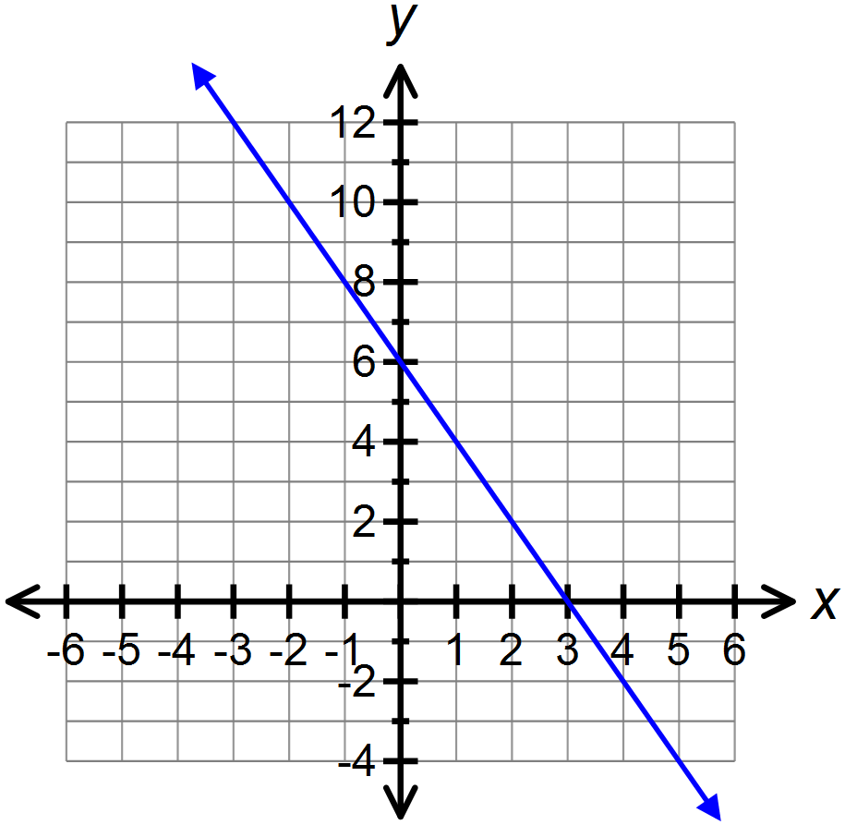2 40. Complete the table and graph $2x+y=6$

$$x$$ | $$y$$
-2 | 10
-1 | 8
0 | 6
1 | 4
2 | 2

41. An amusement park charges an entry fee of $10 and $2 per ride.

1 A) Complete the table

# Rides (R) | Cost ($)  (C)
0 | 10
1 | 12
2 | 14
3 | 16
4 | 18
5 | 20

1 B) Write the equation that relates the cost (C) to the number of rides (R).

$C=2R+10$

1 C) How many rides can a person go on if they have $26? Justify your answer.

8 Rides Students might extend the table, construct graph, or use inspection

1 D) Is this an example of continuous or discrete data. Explain your answer.

This is Discrete Data because a person cannot go on a part of a ride.

3 42. Determine the algebraic expression that represents the shaded region. Simplify your answer.
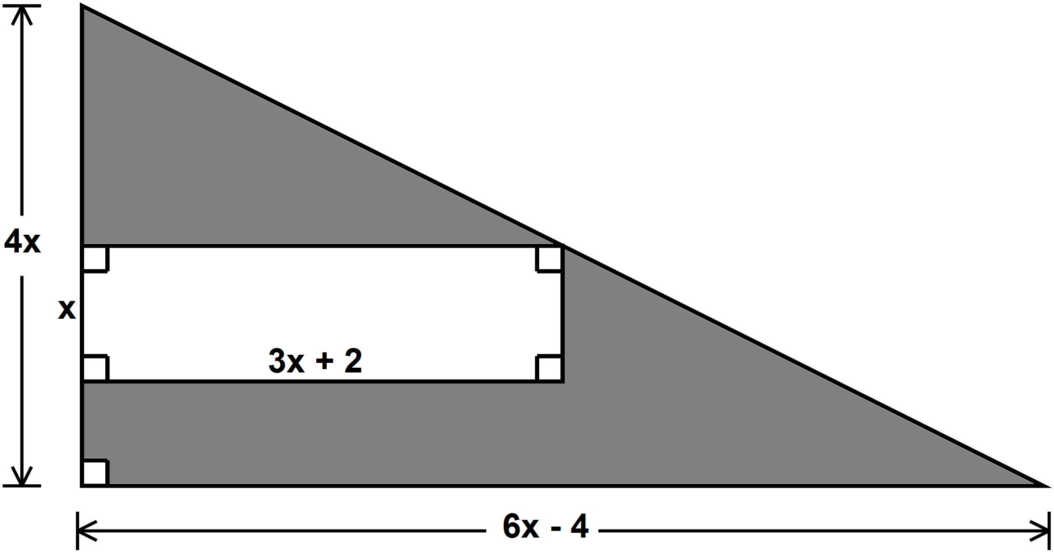
$${Area}_{shaded region}={Area}_{triangle}-{Area}_{rectangle}$$
$\left[\frac{\left(6x-4\right)\left(4x\right)}{2}\right]-\left[\left(3x+2\right)\left(x\right)\right]$ 1 mark
$=\left[\frac{24x^{2}-16x}{2}\right]-\left[3x^{2}+2x\right]$
$=\left(12x^{2}-8x\right)-\left(3x^{2}+2x\right)$ 1 mark
$=9x^{2}-10x$ 1 mark

43. Debbie incorrectly solved the following problem:

$4\left(x-5\right)=28$
Step 1 $4x-5=28$
Step 2 $4x-5+5=28+5$
Step 3 $4x=33$
Step 4 $\frac{4x}{4}=\frac{33}{4}$
Step 5 $x= \frac{33}{4}$

1 a) In which step did Debbie’s error occur?

The error occurred in Step _______1________

Explanation: Debbie did not apply the distributive property correctly in Step 1. She did
not multiply the 4 by the second term of the binomial.

1 b) Solve the equation correctly.

$$4\left(x-5\right)=28$$
$$4x-20=28$$
$$4x-20+20=28+20$$
$$4x=48$$
$$\frac{4x}{4}=\frac{48}{4}$$
$$x=12$$

OR $4\left(x-5\right)=28$
$$x-5=7$$
$$x=12$$

44. John downloads apps from two online stores. The rate plans are shown in the table.

 | iApps | Galaxy Apps
Membership fee | $$\$20$$ | $$\$30$$
Cost per app | $$\$1.25$$ | $$\$0.75$$
Expression | $$20+1.25x$$ | $$30+0.75x$$

3 Write and solve an inequality to determine when the number of iApp downloads costs more than Galaxy Apps downloads.

1 mark$20+1.25x>30+0.75x$
$$1.25x-0.75x>30-20$$
$$0.50x>10$$
$$\frac{0.50x}{0.50}>\frac{10}{0.50}$$
1 mark$n>20$

****After 20 downloads, iApps will cost more. 1 mark

2 45. Draw a reduction of the figure using a scale factor of $\frac{3}{4}$?

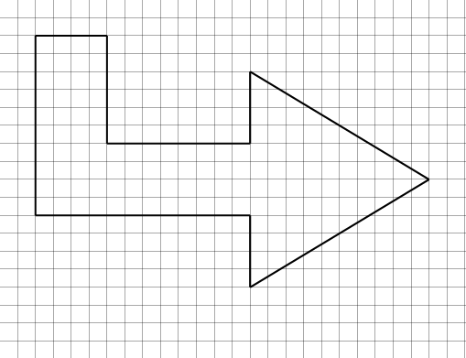

3 46. Both triangles are similar. How long is the bridge?

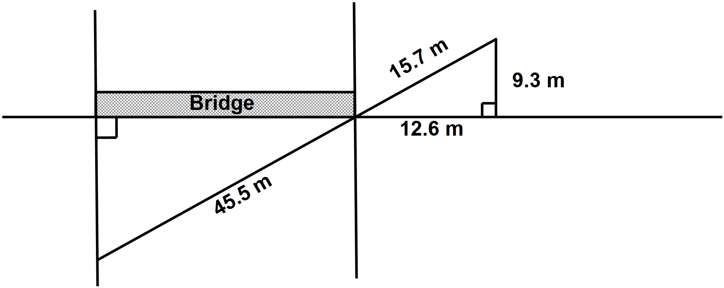Let $x$ = length of bridge
$\frac{x}{12.6}=\frac{45.5}{15.7}$ 1 mark
$15.7x=573.3$
$\frac{15.7x}{15.7}=\frac{573.3}{15.7}$ 1 mark
$x≅36.5 m$ 1 mark
The bridge is $36.5$ metres long.

3 47. Point $O$ is the centre of a circle with radius of $7 cm$. If $PQ=16 cm$, what is the length of tangent $RQ$, to the nearest tenth?

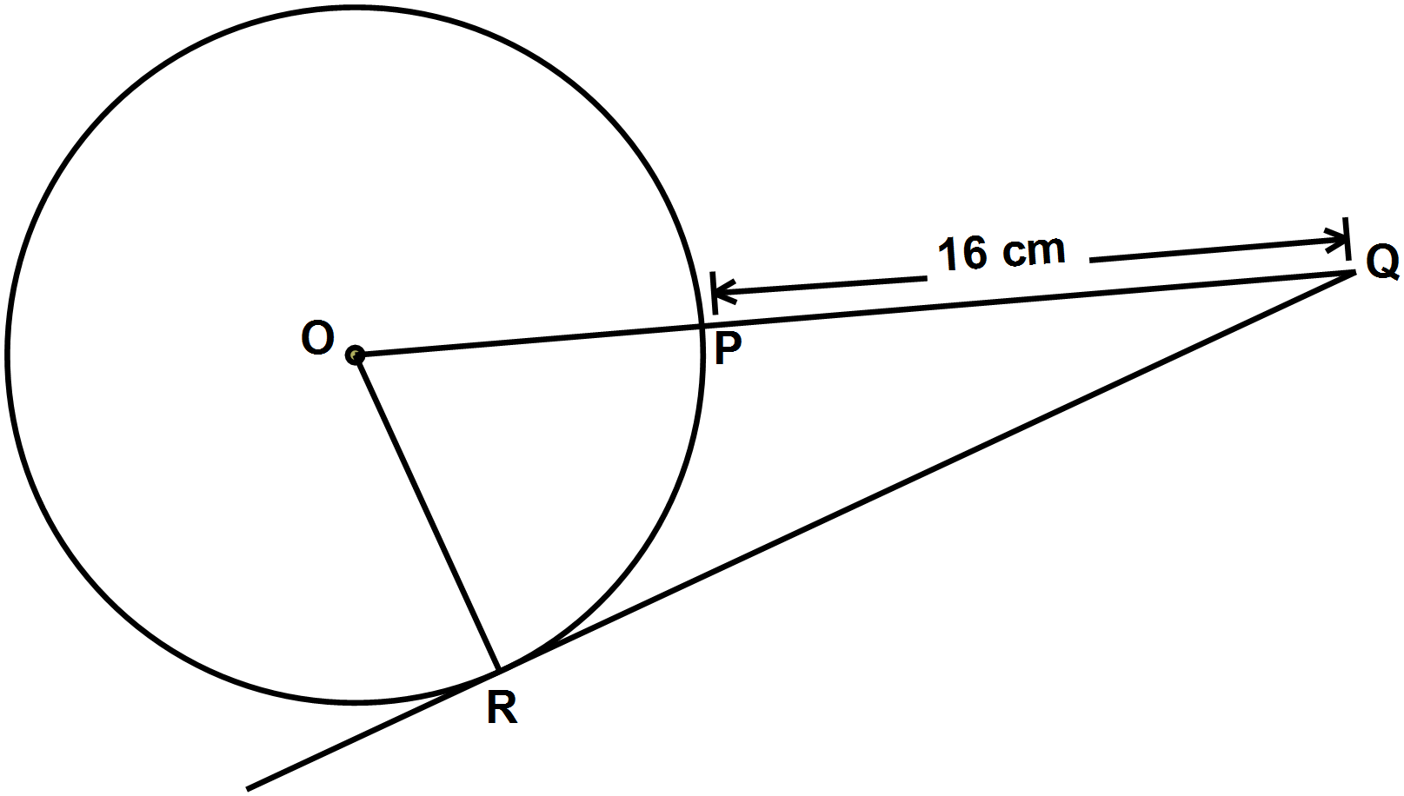
- Indicate that a tangent and radius at point of tangency is a perpendicular bisector or forms a right angle.
[0.5 mark]
- Finding the value of RQ
$x^{2}+7^{2}={23}^{2}$ 0.5 mark
$x^{2}={23}^{2}-7^{2}$ 0.5 mark
$x^{2}=529-49$ 0.5 mark
$x^{2}=480$ 0.5 mark
$x=\sqrt{480}$
$x≅21.9cm$ 0.5 mark
If the hypotenuse is marked as 16 cm rather than 23 cm, deduct 0.5 marks.

Grade 9 Math Multiple Choice Answer Sheet
(This sheet may be removed from the exam paper.)

Teacher: Answer Key Name:_________________

1. C
2. B
3. A
4. C
5. C
6. D
7. B
8. A
9. C
10. C
11. B
12. B
13. B
14. B
15. C
16. B
17. C
18. B
19. C
20. B

21. A
22. C
23. B
24. B
25. B
26. B
27. B
28. C
29. B
30. A
31. B
32. D
33. C
34. C
35. B

