**Grade 9 Math June Exam Review**

**Unit 1: Square Roots and Surface Area**

1**.** Which numbers below are perfect squares? Explain how you know?

A) $\frac{16}{144}$ **yes because both 16 and 144 are perfect squares**

B) 0.049 **no because it has an odd number of decimal places**

C) $\frac{5}{20}$**yes because it reduces to ¼ and both 1 and 4 are perfect squares**

2. Calculate the number whose square root is

A) 2.3 **2.32 = 5.29**

B) **2/3 x 2/3 = 4/9**

**3.** Determine the value of each square root.

A) $\sqrt{\frac{169}{81}}$**= 13/9**

B) $\sqrt{0.0016}$**= 0.**04

C) **= 2.1**

4. A square theatre is divided up into 4 sections.

Sections A and B are also squares. Section A has

an area of 0.25 m2 and Section B has an area of 0.04 m2.

Determine the area of the combined four sections.

**Section A – length = 0.5m**

**Section B – length = 0.2 m**

**Square length = 0.5 + 0.2 = 0.7m**

**Area = 0.72 = 0.49m2**

5. Determine the unknown length to the nearest tenth of a unit.

**A). B).**

**a2 + b2 = c2**

**a2 + 82 = 122**

**a2 + 64 = 144**

**a2 = 80**

**a = 9.5m**

**a2 + b2 = c2**

**42 + 92 = c2**

**16 + 81 = c2**

**97 = c2**

**C = 9.8cm**

6. Determine the surface area of each composite object

|  |  |
| --- | --- |
|  |  |

**SA = 348 + 54 – 2(9) = 384cm2 SA = 31.4 + 96 – 2(3.14) = 121.12cm2**

7. Determine the perimeter of a square with area m2.

**Length = 4/7**

**Perimeter = 4 x length = 4 x 4/7 = 16/7 = 2 2/7 m.**

8. Determine the area of a square with perimeter of 10 m.

**Length = p / 4 = 10/4 = 2.5**

**A = s2 = 2.52 = 6.25m2**

**Unit 2: Powers and Exponent Laws**

1. Write as a single power.

A). **= (-8)3** B). **= 77**  C).  **= 54**

D). **= (-3)2**

2. Evaluate. Show your work.

A). **= 11** B).  **= 16** C). **= -15** D).  **= 8/27**

E).  **= 3**

3. Which statement is true?

(A)  (B) 

(C)  (D)  **true**

4. Evaluate (23)2 and (23)(22) and explain why they are different.

**(23)2 means 23 x 23 = 23+3 = 22 x 3 = 26 while 23 x 22 = 23+2 =25**

5. Using laws of exponents, simplify and then evaluate:****



**= (-1) + (-1) + (-2)1**

**= (-2) + (-2)**

**= -4**

6. Identify and then correct any errors in the student’s work below. Explain how you

think the errors occurred.



**33 + 32 does not equal 35 You only add exponents when you multiply powers.**

**= (27 + 9) 2**

**= 362**

**= 1296**

**Unit 3: Rational Numbers**

1. Which rational number is equal to ? A). B). **C).**  D).

2. Which letter on the number line represents the rational number -0.9? **D**



3. Arrange the rational numbers in order from LEAST to GREATEST. $\frac{-5}{8}$, $-\frac{3}{4}$, $-\frac{1}{2}$, $-\frac{3}{8}$

**-3/4 , -5/9, -1/2, -3/9**

4. Which rational number would make the statement true? $-1.2-\boxed{}=3.7$?

1. 2.5 **B) -2.5** C) -4.9 D). 4.9

5. Which of the following products or quotients would be greater than 0?

A). (-1.2) $×$ 0.3 **B). $\left(-\frac{3}{4}\right) × \left(-\frac{4}{5}\right)$** C). (-0.32) 1.6 D).

6. The solution to the following calculation is incorrect. Identify the step in which the

error was made.

$$-\left(3.7\right)×\left(2.8+-1.5\right)-4.8÷(-1.2)$$

Step One: $\left(-3.7\right)×\left(1.3\right)-4.8÷\left(-1.2\right)$

Step Two: $-4.81-4.8÷-1.2$

Step Three: $-9.61÷(-1.2)$

Step Four: $8.008\overline{3}$

**They did the incorrect order of operations in Ste 1. You need to multiply and divide before adding and subtracting.**

7. Calculate. All answers must be in simplest form (lowest terms).

1. $\frac{11}{3}—\frac{17}{4}$**= -1 3/4** B) $1\frac{5}{8}+\left(-6\frac{1}{3}\right)$**= -5 7/24** C) $\frac{9}{5}×(6\frac{1}{3})$**= 11 2/5**

D) $-\frac{1}{3}÷\frac{5}{12}$**= -4/5**

E) $\frac{2}{3} × \left(-\frac{1}{2}\right)+ \frac{5}{6}$**= ½**  F)  **= -40.55**

8. A thermometer on a freezer is set at -5.50C. Each time the freezer door is opened, the

temperature increases by 0.30C. Suppose there is a power outage. How many times can the door by opened before the temperature of the freezer increases to 50C? Show how you found your answer. **-5.5 + 0.3n = 5, n = 35 times**

9. There are  cups of flour in a recipe for one dozen oatmeal cookies. How many cups

of flour are needed for dozen cookies? a)  b) c) **d)**

10. A dump truck can hold  tonnes of gravel. How many trips are needed to move 35

tonnes of gravel using this truck? a) 9 **b)10**  c)131 d)132

11. The temperature in Florida is 18.4  on the first of this month. The temperature in

Yellowknife is –24.8 . Write the **equation** to find the difference in temperature

between the 2 locations. Be sure to state the answer and show the proper signs.

**18.4 – (-24.8 = 43.2 The difference in temps is 43.2 ˚C.**

12. A submarine descended at a rate of 23.4 meters per minute. Write the **equation** to find

the depth of the submarine after 18.5 minutes. Be sure to state the answer and show

the proper signs. **(-23.4)(18.5) = -432.9 He descended 432.9 m**

**Unit 4: Linear Relations**

1. Which equation describes each graph? Show workings or justify your choice.



(a) (b) (c)

|  |  |  |  |  |  |  |  |  |  |  |  |  |  |  |  |  |  |  |  |  |  |  |  |  |  |  |
| --- | --- | --- | --- | --- | --- | --- | --- | --- | --- | --- | --- | --- | --- | --- | --- | --- | --- | --- | --- | --- | --- | --- | --- | --- | --- | --- |
| |  |  | | --- | --- | | **x** | **y** | | **-2** | **3** | | **0** | **1** | | **2** | **-1** |   **Line b)** | |  |  | | --- | --- | | **x** | **y** | | **-2** | **-8** | | **0** | **-2** | | **2** | **4** |   **Line a)** | |  |  | | --- | --- | | **x** | **y** | | **-2** | **0** | | **0** | **4** | | **2** | **\*** |   **Line c)** |

2. Graph each equation.

a) 2 $y=-4$**y = -2**  b) $x+2=7$**x = 5**



~~Why do we need a table of values for part b) but not for a)?~~

3. Jane cleans houses for $25 plus $12 per hour.

1. Write an equation that relates the charge, *C* dollars, to the number of hours, *n*.

**C = 25 + 12n**

1. Create a table that shows the **charges** when Jane cleans for up to 5 hours.

|  |  |  |  |  |  |
| --- | --- | --- | --- | --- | --- |
| n | 1 | 2 | 3 | 4 | 5 |
| C | 37 | 49 | 61 | 73 | 85 |

1. Graph the above table of values (Be sure to label the axis appropriately and give the graph a title)



**Plot points and DON NOT connect**

1. Use the graph to determine what will the charge be when Jane cleans for 8 hours? (Be sure to show how you determined this on the graph)
2. How many hours will Jane have to clean to earn $49? **2 h**
3. Look at the pattern and assume it continues.



1. Fill in the table below using the diagrams (complete the pattern of diagrams)

|  |  |  |  |  |  |  |
| --- | --- | --- | --- | --- | --- | --- |
| # of Triangles (T) | 1 | 2 | 3 | 4 | 5 | 6 |
| # of Line Segments (L) | 3 | 5 | **7** | **9** | **11** | **13** |

1. Graph the data on grid paper.



**Plot points and DON NOT connect**

1. Find an equation relating T and L. **L = 2T + 1**
2. How many line segments would there be if you had:
3. triangles **__15___** 20 triangles **__41___** 80 **triangles _161___**
4. Complete a table of values for each equation.

(Use x = -2, -1, 0, 1, 2)

A) $y=2x+1$ B)

|  |  |  |  |  |  |  |  |  |  |  |  |  |  |  |  |  |  |  |  |  |  |  |  |  |  |
| --- | --- | --- | --- | --- | --- | --- | --- | --- | --- | --- | --- | --- | --- | --- | --- | --- | --- | --- | --- | --- | --- | --- | --- | --- | --- |
| |  |  | | --- | --- | | **x** | **y** | | **-2** | **-3** | | **-1** | **-1** | | **0** | **1** | | **1** | **3** | | **2** | **5** | | |  |  | | --- | --- | | **x** | **y** | | **-2** | **0** | | **-1** | **2** | | **0** | **4** | | **1** | **6** | | **2** | **8** | |

**Unit 5: Polynomials**



1. Write an expression to represent the

perimeter of the diagram to the right.

**P = 12x + 4**



1. If the perimeter of the triangle shown to the right is 6t2 - 4 with two know sides given on the diagram, what is the measure of the unknown side?

**-2t+ 4**

3) Write a multiplication sentence and a division sentence to represent the algebra tile model below.



**2x(x + 3) = 2x2 + 6x**

1. Perform the operations as indicated and be sure to simplify your answers.
2.  **= 3m2 – 2m + 2**
3. B)  **= y2 – 12y -2**
4.  **= 12k4 – 6k3 + 42k2 – 6k**
5. D)  **= 3t - 1**
6.  **= -7p2 – 3p - 2**
7. Determine the area of the shaded regions.

6x - 2



4x

**A = 6x2 + 13x A = 21x2 -7x**

1. A student subtracted $\frac{14a^{3}- 8a^{4}}{2a}$ like this:

$\frac{14a^{3}- 8a^{4}}{2a}$

= $7a^{3}- 4a^{4}$

Explain the error(s) and do it correctly.

**Dividing by 2a means dividing by 2a1. They did not subtract the exponent 1.**

1. What is the opposite of ? **-4x2 + 3x - 2**

1. Write the binomial with numerical coefficient 4, degree 2, variable x and constant

term -1.

**4x2 - 1**

1. What is the degree of A) 2xy – 4 **2**  B) 3x2y – 7x6y2? **8**

9) Give an example of each of the two cases in which an expression is not a polynomial.

**Any expression with a) $\sqrt{x}$ or b) division by x**

**Unit 6: Equations and Inequalities**

1. What is the solution to the equation represented by the algebra tiles?

Shaded represents positive. Un-shaded represents negative.

**x = 6**



2. What is *p* if , *p* ≠ 0? **p = 3**



3. Give the inequality graphed on each line

**x<2**

**x>2**

B)

A)



**x>1**

**x<1**

D)

C)



4. Solve the inequality and graph the solution.





6

**-3n + 6 ≤ 12 – 4n**

**-3n + 6 – 6 ≤ 12 – 6 – 4n**

**-3n ≤ 6 – 4n**

**-3n + 4n ≤ 6 -4n + 4n**

**n ≤ 6**

4. Christine wants to go to the fair. Admission costs $4.50 and each ride costs another $1.25.

Christine only has $25.00. How many rides can she go on?

a) Write an inequality to model this problem.   
b) Solve the inequality.

**4.50 + 1.25r ≤ 25**

**1.25 n ≤ 20.50**

**n≤16.4**

**They can take 16 rides or less**

5. Solve

a) 4 + 2x = -3(x – 8) b) $\frac{2}{3}$ x - 7 = $\frac{1}{4}$ c) $\frac{x+3 }{2}= \frac{x-7}{4}$ d) 6.2 + 2.3(3x – 7.3) = x

4 + 2x = -3x + 24 24/3 x – 84 = 12/4 $\frac{4x+12 }{2}= \frac{4x-28}{4}$ 6.2 + 6.9x – 16.79 = x

2x = -3x + 20 8x – 84 = 3 2x + 6 = x – 7 6.9x – 10.59 = x

5x = 20 8x = 87 2x = x – 13 -10.59 = -5.9x

x = 4 x = 10 7/8 x = -13 x = 1.8

e) ½ ( x + 6) = ¾ ( x – 2) f) $\frac{5}{x}- 4= 6$

$\frac{x+6}{2}=\frac{3x-6}{4}$**5/x = 10**

$\frac{4x+24}{2}=\frac{12x-24}{4}$**5 = 10x**

**2x + 12 = 3x – 6 x = ½**

**-x + 12 = -6**

**-x = -18**

**x = 18**

6. For a large pizza, Pizza King charges $12 plus 1.50 per topping. Pizza Queen charges $10 and $1.75 per topping. Write an equation you can solve to determine how many toppings you could have for both pizzas to cots the same.

**12 + 1.50t = 10 + 1.75t**

**1.50t = -2 + 1.75t**

**-0.25t = -2**

**t = 8 For 8 toppings, both pizzas would cost the same.**

**Unit 7: Similarity and Transformations**

1. A surveyor made the measurements as shown in the diagram below. How

wide is the river ($\overline{AB}$), in metres?



$$\frac{18}{20}=\frac{x}{8}$$

**20x = 144**

**X = 7.2m wide**

2. Which statement is true?

1. If ∆ABC ~∆XYZ, then matching angles are equal.
2. If ∆ABC ~∆XYZ, then matching angles are never equal.
3. If ∆ABC ~∆XYZ, then matching sides are equal.
4. If ∆ABC ~∆XYZ, then matching sides has a scale factor of 1.

3. Given the diagram as shown, what is the length of $\overline{PQ}$, in centimeters?



4. Given the diagram below, which statement is correct?

A). ST = TR S Z Y

YZ XY

B). ST = TR

XZ YZ

C). SR = TR T R

XZ ZY

D). SR = TR X

YZ ZX

canflg

1. How many lines of symmetry does the Canadian flag have?

**one**

7. What is the order and angle of rotation symmetry for this figure?



**Order is 3, angle is 360 ˚ ÷ 3 = 120˚**

8. Alice marked out the following triangles to determine the length of the

pond, $\overline{AB}$.



1. Write a similarity relation.
$$\frac{AB}{ED}=\frac{AC}{DC}=\frac{BC}{EC}$$

2. Determine the length of the pond, $\overline{AB}$.

$$\frac{x}{4}=\frac{15}{3}$$

$$3x=60$$

$$x=20$$

**Unit 8: Circle Geometry**

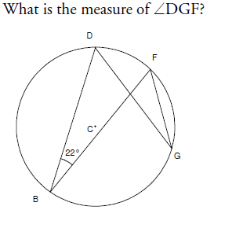

**x = 2 x 56 = 112˚**

**y = 56˚**

**<DGF = 22˚**

1.

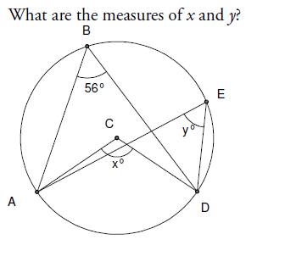

2.

3.

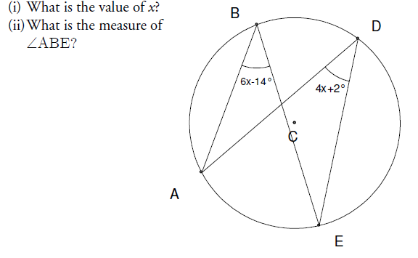

**6x – 14 = 4x + 2 <ABE = 6(8) - 14**

**2x – 14 = 2 = 34˚**

**2x = 16**

**x = 8**

4. Point O is the center of the circle. **x = 90˚**

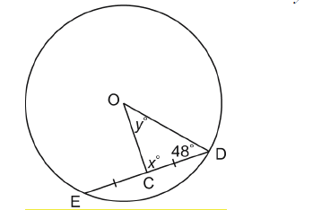

Determine the values of xo and yo. **y = 42˚**

5. Point O is the center of the circle.

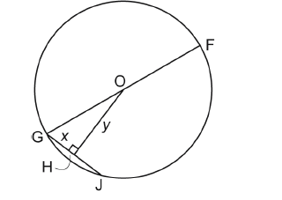

OF = 15 cm and GJ = 11 cm. **x = 5.5 cm**

Determine the values of x and y **y = 14.0 cm**

to the nearest tenth of a centimeter

where necessary.

6. A circle has a diameter of 80 cm. A chord in the circle is 60 cm long. How far is the

chord from the center of the circle, to the nearest tenth of a centimeter? **26.5cm**

7. A circle has a diameter of 24 cm. Two chords are drawn on opposite side of the

center of the circle. One chord is 17 cm long and the other chord is 13 cm long.

Which chord is closer to the center of the circle? How much closer if this chord, to the

nearest tenth of a centimeter? **The 17cm chord is 11.3 – 8.4 = 1.9cm closer.**

8. Point O is the center of each circle. Determine the values of xo and yo. Justify your

solutions.

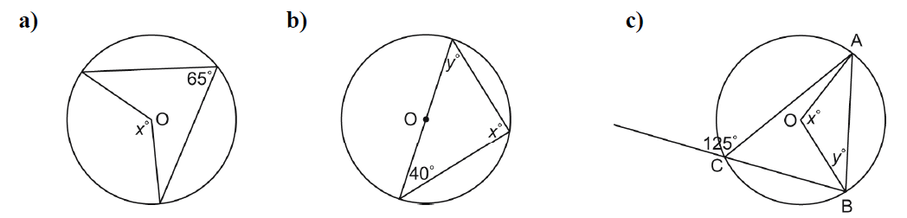

**x = 2 x 65 = 130˚ x = 90˚, y = 50˚ x = 2 x 55 = 110˚,**

**y = (180-110) ÷ 2 = 35˚**

**x = 60˚**

**y= 30˚**

**z = 30˚**

**w = 30˚**

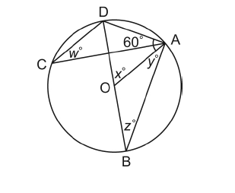

9. Point O is the center of the circle and DB is

the diameter. Determine the values of

wo, xo, yo and zo. Justify your solutions.

**Unit 9: Probability and Statistics**

1. Tell if the following decisions are based on theoretical probability, experimental probability or subjective judgement.

a) According to a stats Canada survey, only 50% of households save money. Sara concludes that 3 out of her 6 teachers save money. **Experimental**

b) The last three times Mark went to the gym on Saturday morning it was too crowded. This week he decided to go in the afternoon. **Experimental**

c) If you toss a coin 100 times you should get 50 heads. **Theoretical**

d) Ian felt lucky and bought a lottery ticket. **Subjective Judgement**

e) There are 2 green and 3 red marbles in a bag. Tim concludes that there is a better chance of picking a red. **Theoretical**

2. Describe the problem with the following surveys or survey questions.

a) After just receiving their report cards, students were asked “What is your favourite subject?”.

**Timing: The timing of this question is biased.**

b) A group of grade 9 students are asked “What do you think of this childish carnival idea?”. **: The wording of this question is biased.**

c) A telephone survey asks people “Which church to you go to?”. **Cultural Sensitivity: not all people go to church.**

d) A grade 7 student decides that he is going to call everyone in Toronto to ask if they know where St. John’s is located. **Time: This would take forever!**

3. In the following situations tell whether it would be best to use a sample or a population and tell why.

a) You want to check the quality of Costco bakery bagels. **Sample: you cannot taste all of the bagels.**

b) You want to know if Canadians over 50 fear Global warming. **Sample: It would take a lot of time and money to contact the entire population of 50 year old plus Canadians.**

c) A company wants to check the quality of their new mass produced video game system. **Sample: it would take too much time and too much money to test them all.**

d) Wildlife services wants to determine the rabies rates amongst rabbits in the province. **Sample: It would be impossible to ctach every rabbit in the province – time!**